MULTIPLICATION AND DIVISION
Pearson Edexcel - Tuesday 21 May 2019 - Paper 1 (Non-Calculator) Foundation Tier

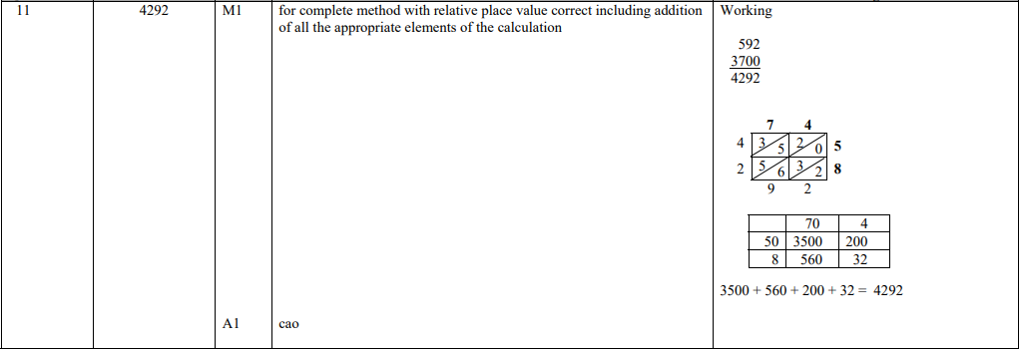

Pearson Edexcel – Specimen 2 - Paper 1 (Non-Calculator) Foundation Tier

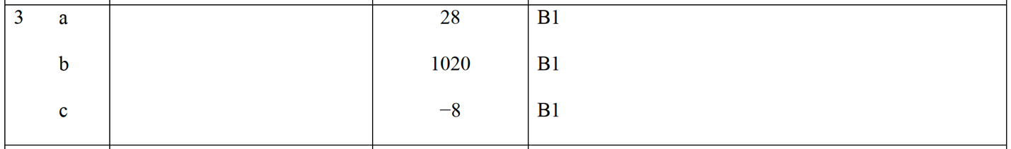

Pearson Edexcel – Specimen 1 - Paper 1 (Non-Calculator) Foundation Tier

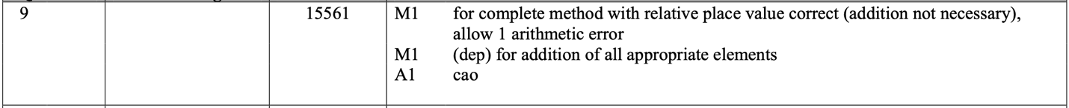
OCR Thursday 07 November 2019- Morning (Non-Calculator) Foundation Tier

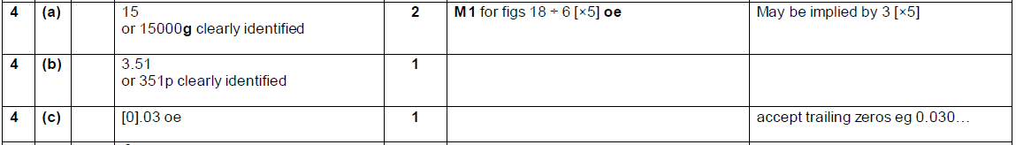

OCR Monday 11 November 2019 – Afternoon (Calculator) Foundation Tier

OCR Tuesday 21 May 2019 – Morning (Calculator) Foundation Tier
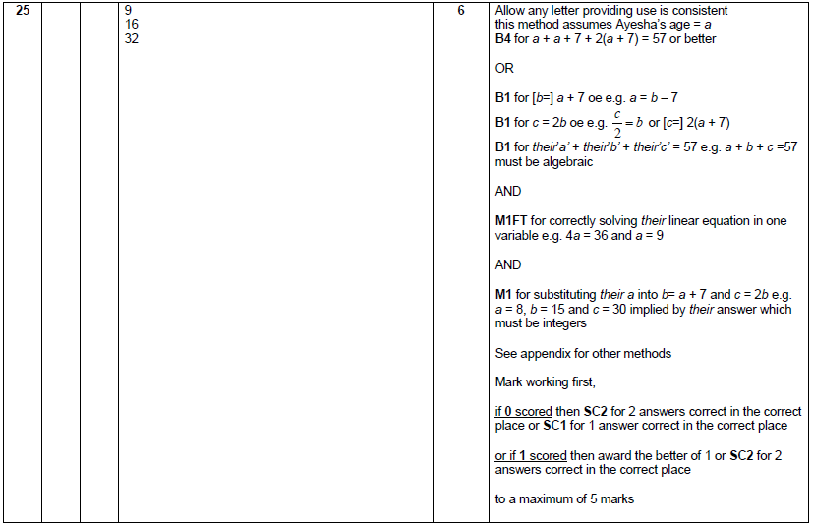

OCR Thursday 6 June 2019 – Morning (Non-Calculator) Foundation Tier
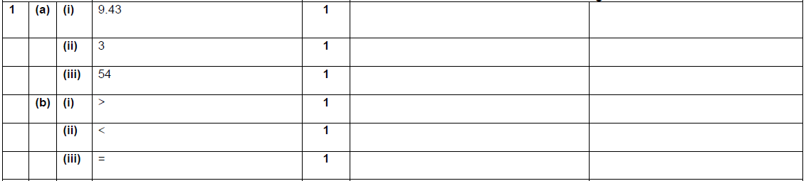

OCR Thursday 8 November 2018 – Morning (Non-Calculator) Foundation Tier
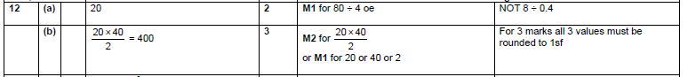

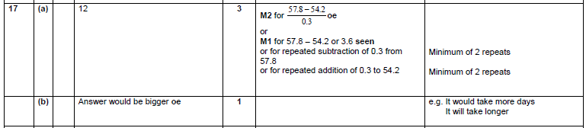

OCR Monday 12 November 2018 – Morning (Calculator) Foundation Tier

Pearson Edexcel – Sample Papers - Paper 1 (Non-Calculator) Foundation Tier

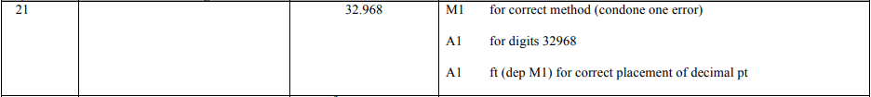
OCR Sample Question Paper 1 – Morning/Afternoon (Calculator) Foundation Tier

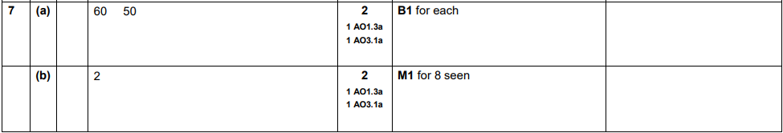

AQA Tuesday 19 May 2020 – Morning (Non-Calculator) Foundation Tier

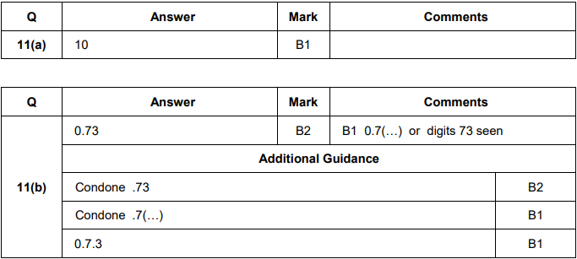
AQA Tuesday 21 May 2019 – Morning (Non-Calculator) Foundation Tier

AQA Thursday 11 June 2019 – Morning (Calculator) Foundation Tier

AQA Tuesday 6 November 2018 – Morning (Non-Calculator) Foundation Tier

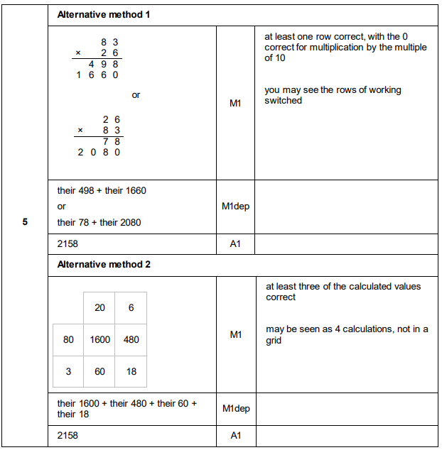
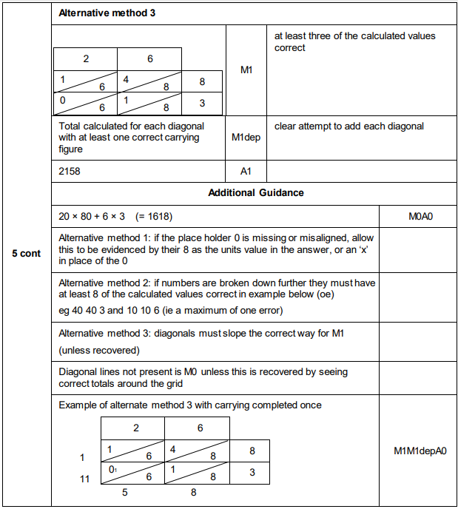

AQA Thursday 7 June 2018 – Morning (Calculator) Foundation Tier

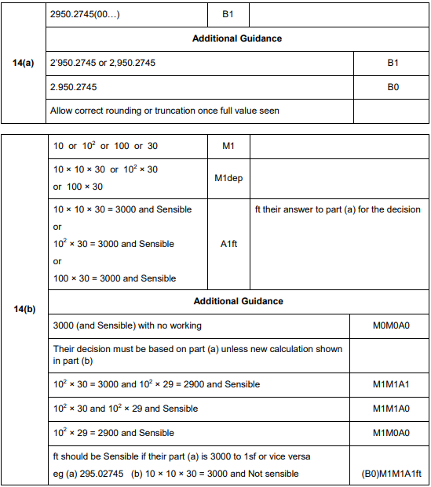

AQA Thursday 25 May 2017– Morning (Non-Calculator) Foundation Tier

